Experiment13: Wireshark
i. Packet Capture Using Wire shark
ii. Starting Wire shark
iii. Viewing Captured Traffic
iv. Analysis and Statistics & Filters.

Wireshark is a network protocol analyzer, or an application that captures packets from a network connection,
How does Wireshark work? Wireshark is a packet sniffer and analysis tool. It captures network traffic from ethernet, Bluetooth, wireless (IEEE. 802.11), token ring, and frame relay connections, among others, and stores that data for offlin
Why is it called Wireshark?
It is used for network troubleshooting, analysis, software and communications protocol development, and education. Originally named Ethereal, the project was renamed Wireshark in May 2006 due to trademark issues.
Is Wireshark a software?

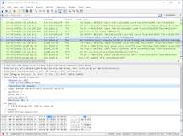
Wireshark is an open source software project, and is released under the GNU General Public License (GPL
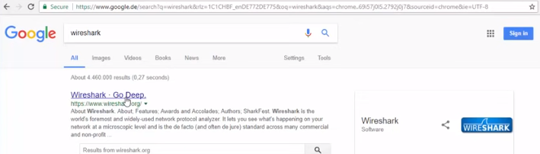

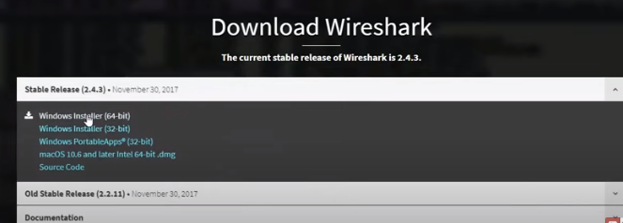

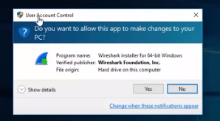

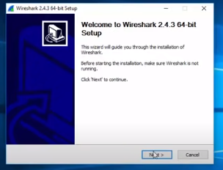

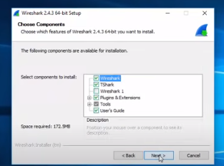

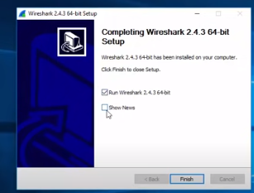

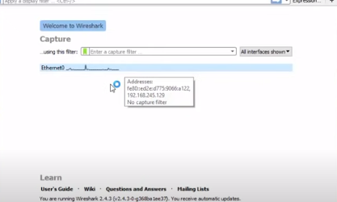
i.packet capture using wire shark
What is packet capture used for?
Packet capturing helps to analyze networks, manage network traffic, and identify network performance issues. It allows IT teams to detect intrusion attempts, security issues, network misuse, packet loss, and network congestion. It enables network managers to capture data packets directly from the computer network

How does Wireshark capture packets?
Wireshark uses pcap to capture packets, so it can only capture packets on the types of networks that pcap supports. Data can be captured "from the wire" from a live network connection or read from a file of already-captured packets.

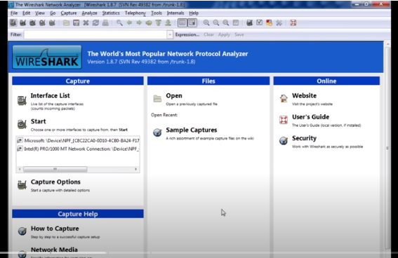

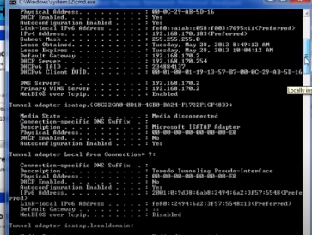

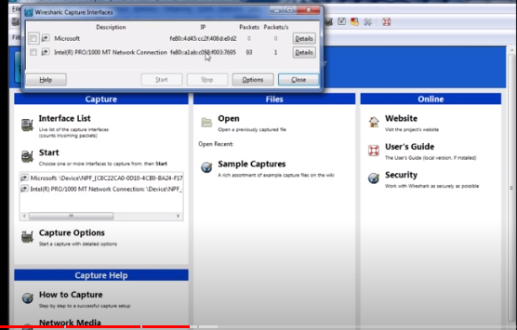

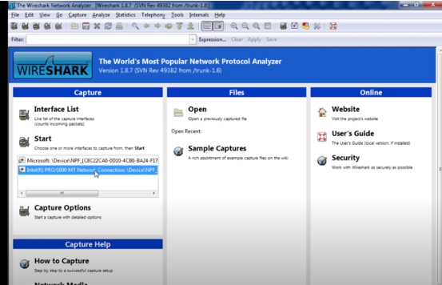

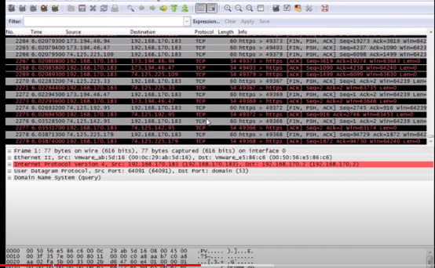

ii)Starting wire shark

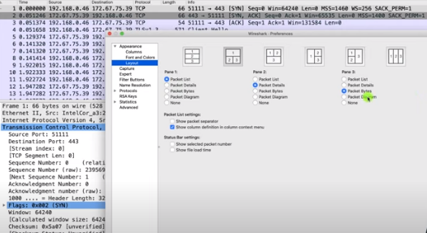

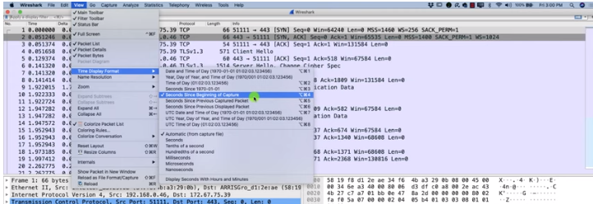

iii) viewing captured trafic

Viewing Packets You Have Captured
Once you have captured some packets or you have opened a previously saved capture file, you can view the packets that are displayed in the packet list pane by simply clicking on a packet in the packet list pane, which will bring up the selected packet in the tree view and byte view panes.
Figure 6.1. Wireshark with a TCP packet selected for viewing
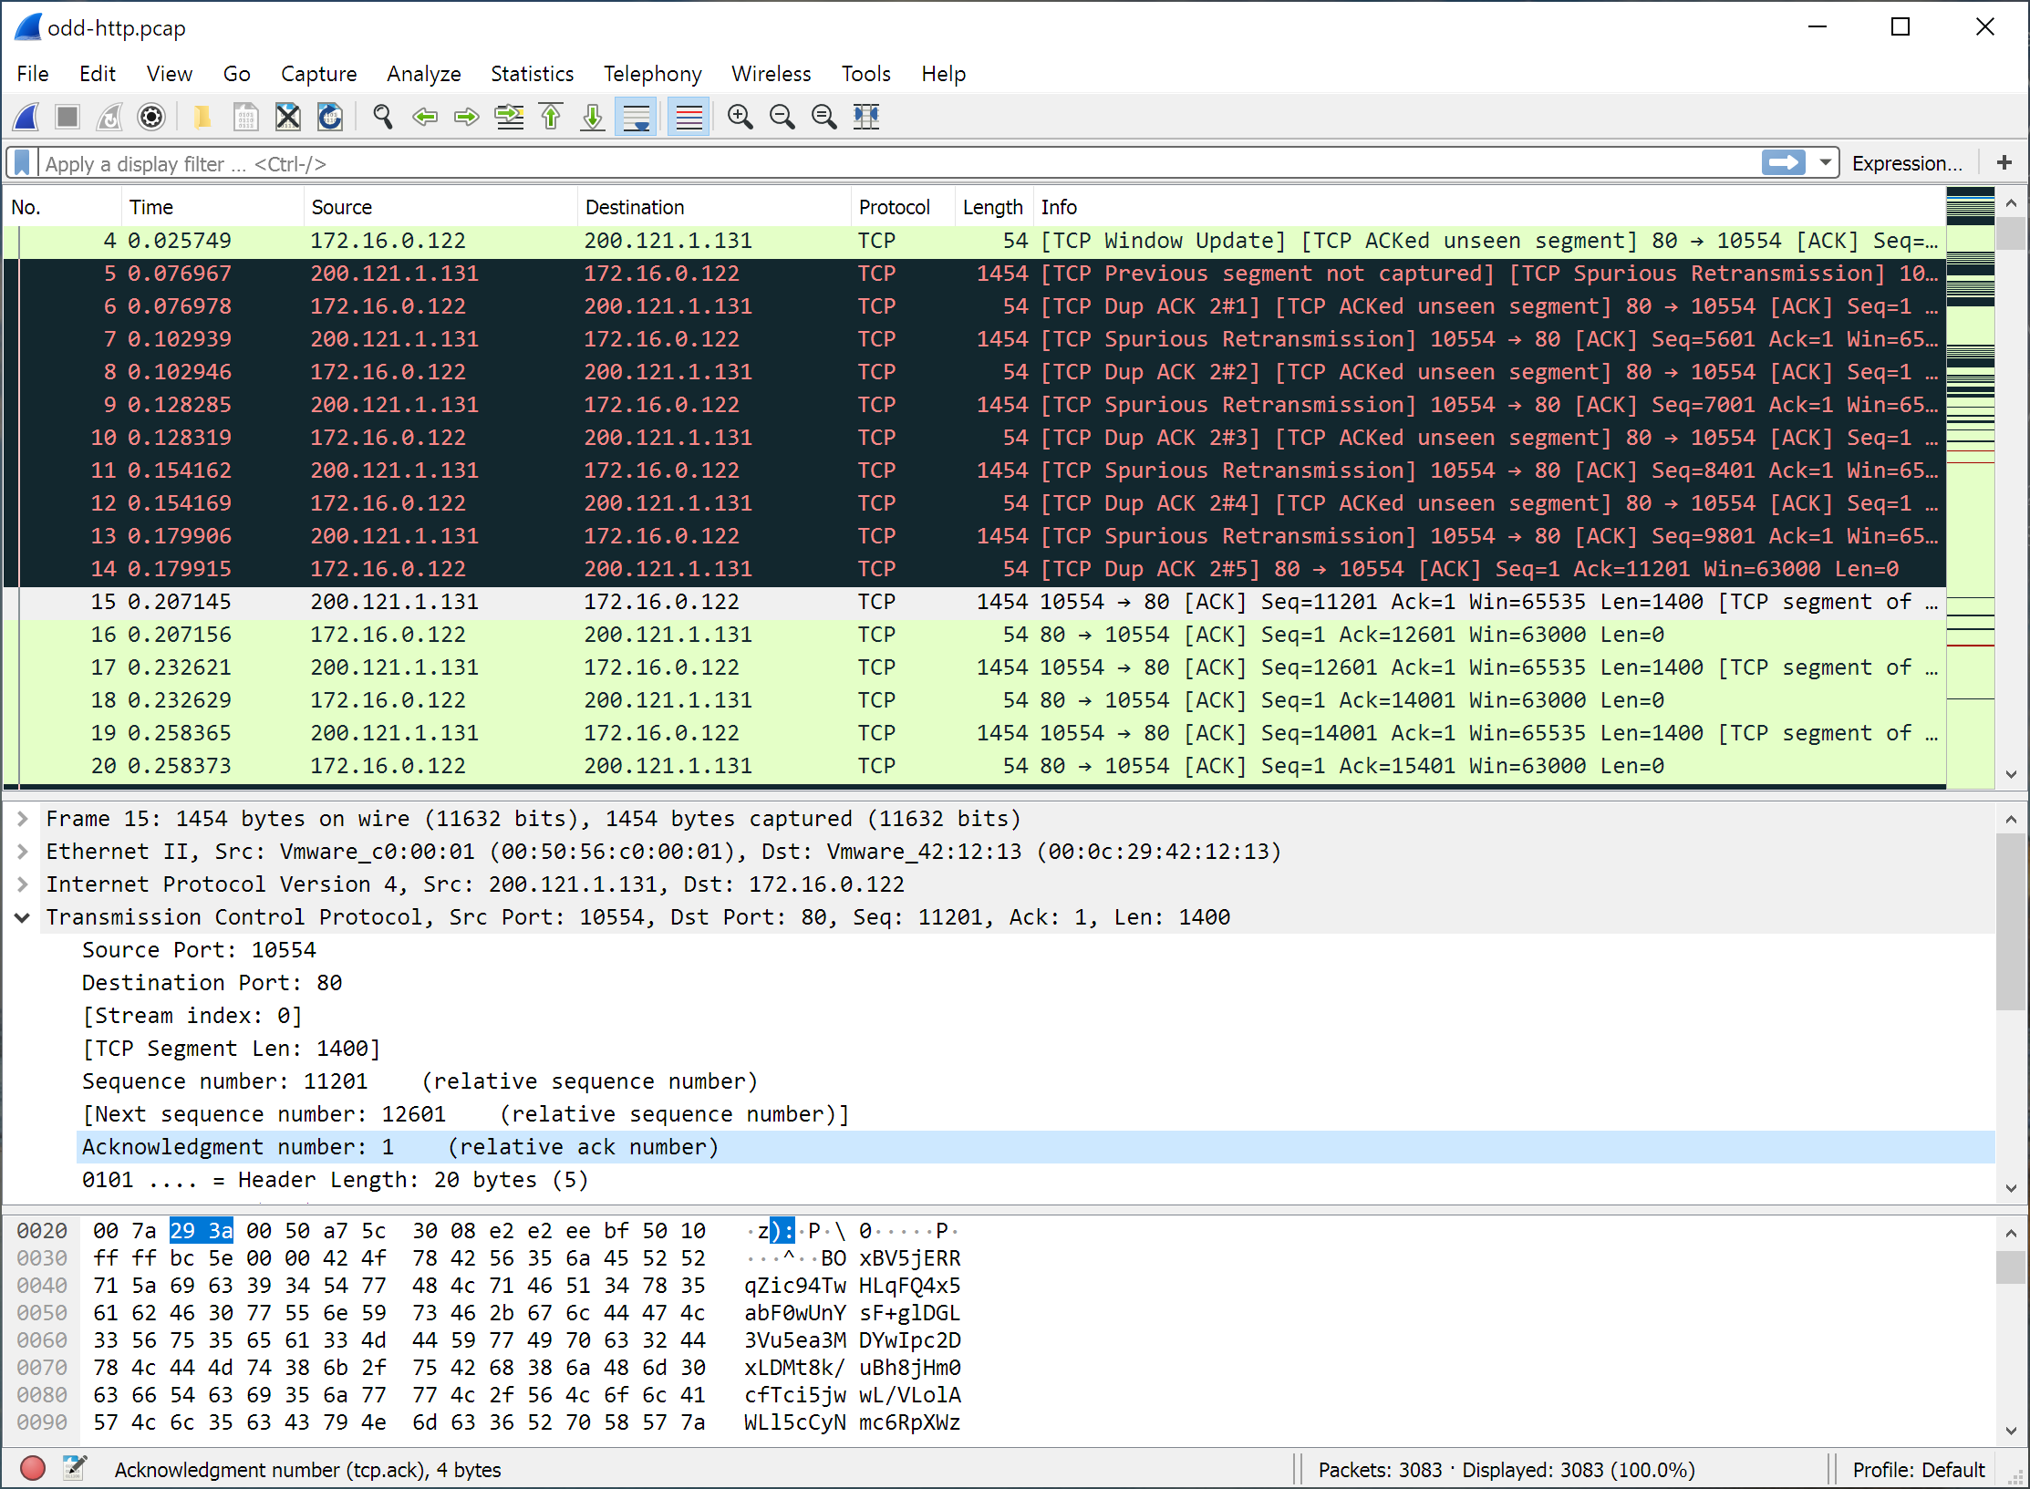
.
Figure 6.2. Viewing a packet in a separate window
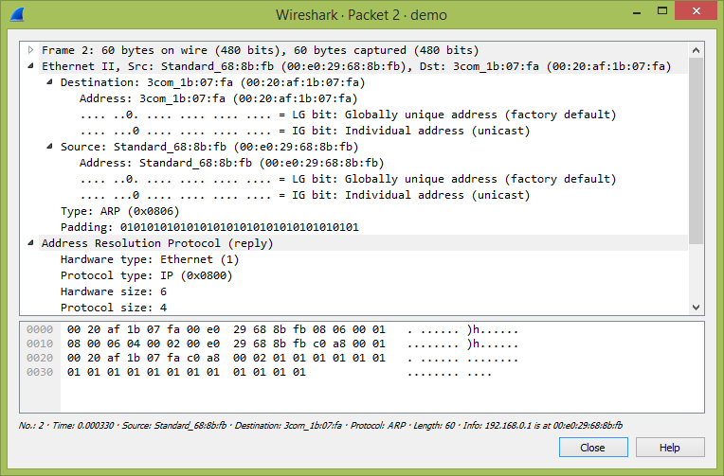

iv)analysis and statistics & filters

When exploring data it can be useful to analyse a subset of the cases from the dataset, for example to see summary statistics for just Male or Female subjects.
To allow analysis of just a subset of cases Analyse-it only analyses the cases that are visible on the worksheet. Observations on hidden rows will not be included in the analysis. Rows can be manually hidden to exclude them from analysis, or Excel's AutoFilter or Advanced Filter can be used to hide rows based on conditions:
- A specific value or category, e.g. filter by Sex to just show Female cases.
- A range of the highest or lowest values of the variable. The number of values to show, e.g. 10, or a percentage of the total number of values, e.g. show 10% of the top values, can be chosen.
- A boolean condition using operators such as <, >, <=, >= and using boolean AND or OR to combine up to two conditions.

IMPORTANT When Analyse-it updates a report it will analyse the cases that are currently visible in the dataset, rather than the cases that were visible when the analysis was first performed.
To use AutoFilter to limit analysis to a subset of the dataset:
- Select a cell in range containing a List dataset.
- Click Filter on the Analyse-it tab/toolbar.
- Excel shows drop-down arrows alongside the names of the variables of the dataset. Click the drop-down arrow then click the value to filter to, Top 10... to filter to a range of values, or Custom... to use a boolean condition.
- Analyse-it will now analyse just the subset of the dataset.
14. How to run Nmap scan

How to Run a Simple Nmap Scan
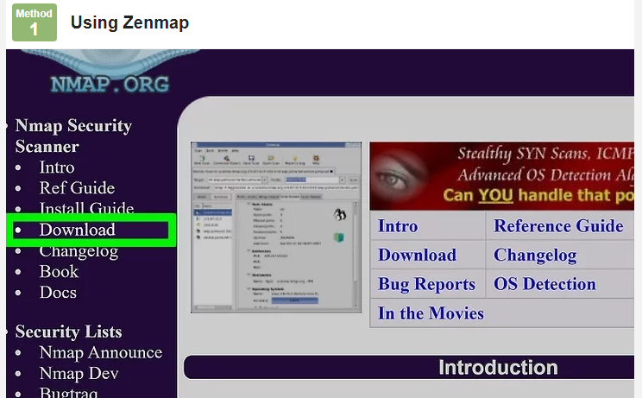

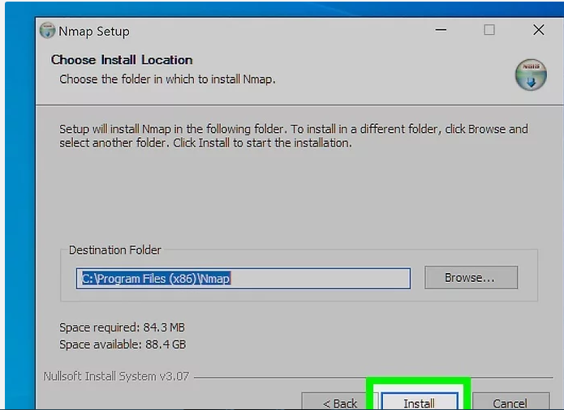

2
Install Nmap. Run the installer once it is finished downloading. You will be asked which components you would like to install. In order to get the full benefit of Nmap, keep all of these checked. Nmap will not install any adware or spyware.

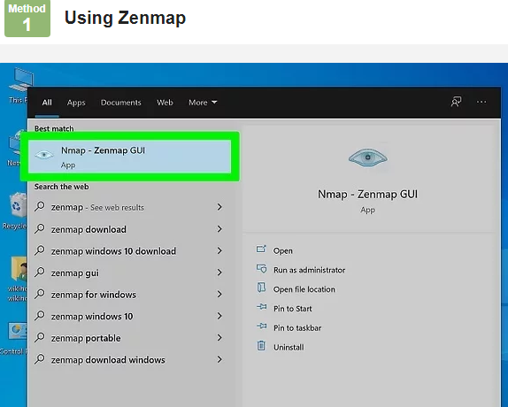

3
Run the “Nmap – Zenmap” GUI program. If you left your settings at default during installation, you should be able to see an icon for it on your desktop. If not, look in your Start menu. Opening Zenmap will start the program.
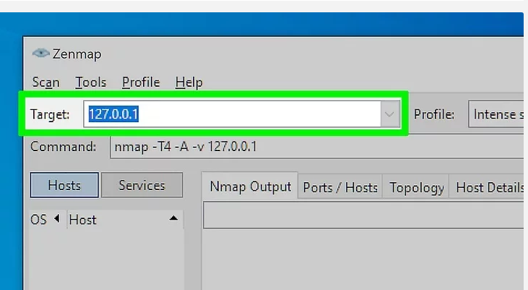

4
Enter in the target for your scan. The Zenmap program makes scanning a fairly simple process. The first step to running a scan is choosing your target. You can enter a domain (example.com), an IP address (127.0.0.1), a network (192.168.1.0/24), or a combination of those

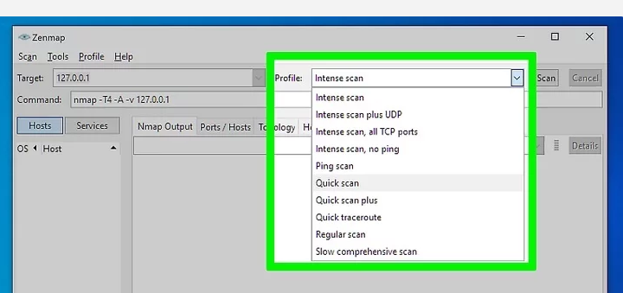

5.Choose your Profile. Profiles are preset groupings of modifiers that change what is scanned. The profiles allow you to quickly select different types of scans without having to type in the modifiers on the command line. Choose the profile that best fits your needs:[1]
- Intense scan - A comprehensive scan. Contains Operating System (OS) detection, version detection, script scanning, traceroute, and has aggressive scan timing. This is considered an intrusive scan.
- Ping scan - This scan simply detects if the targets are online, it does not scan any ports.
- Quick scan - This is quicker than a regular scan due to aggressive timing and only scanning select ports.
- Regular scan - This is the standard Nmap scan without any modifiers. It will return ping and return open ports on the target.

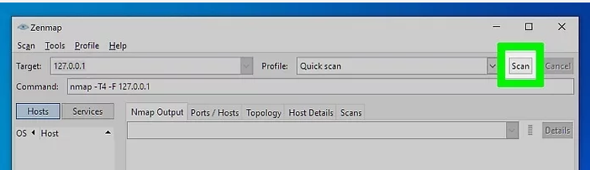

6
Click Scan to start scanning. The active results of the scan will be displayed in the Nmap Output tab. The time the scan takes will depend on the scan profile you chose, the physical distance to the target, and the target’s network configuration.

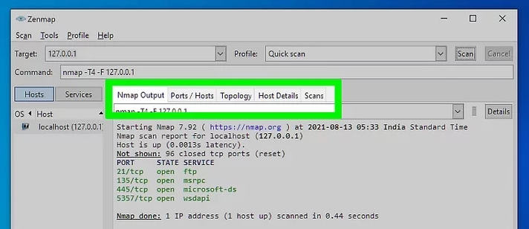
7
Read your results. Once the scan is finished, you’ll see the message “Nmap done” at the bottom of the Nmap Output tab. You can now check your results, depending on the type of scan you performed. All of the results will be listed in the main Nmap Output tab, but you can use the other tabs to get a better look at specific data.[2]
- Ports/Hosts - This tab will show the results of your port scan, including the services for those ports.
- Topology - This shows the traceroute for the scan you performed. You can see how many hops your data goes through to reach the target.
- Host Details - This shows a summary of your target learned through scans, such as the number of ports, IP addresses, hostnames, operating systems, and more.
- Scans - This tab stores the commands of your previously-run scans. This allows you to quickly re-scan with a specific set of parameters.
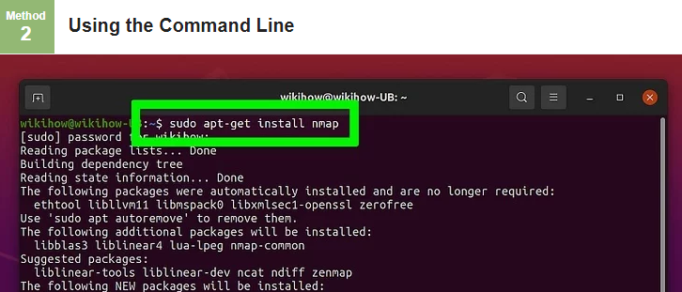

- Install Nmap. Before using Nmap, you will need to install it so that you can run it from the command line of your operating system. Nmap is small and available for free from the developer. Follow the instructions below for your operating system:
  - Linux - Download and install Nmap from your repository. Nmap is available through most of the major Linux repositories. Enter in the command below based on your distribution:
    - Red Hat, Fedora, SUSE
rpm -vhU http://nmap.org/dist/nmap-6.40-1.i386.rpm (32-bit) OR
rpm -vhU http://nmap.org/dist/nmap-6.40-1.x86_64.rpm (64-bit)
    - Debian, Ubuntu
sudo apt-get install nmap
  - Windows - Download the Nmap installer. This can be found for free from the developer’s website. It is highly recommended that you download directly from the developer to avoid any potential viruses or fake files. Using the installer allows you to quickly install the command line Nmap tools without having to worry about extracting to the right folder.
    - If you don’t want the Zenmap graphical user interface, you can uncheck it during the installation process.
  - Mac OS X – Download the Nmap disk image. This can be found for free from the developer’s website. It is highly recommended that you download directly from the developer to avoid any potential viruses or fake files. Use the included installer to install Nmap on your system. Nmap requires OS X 10.6 or later.

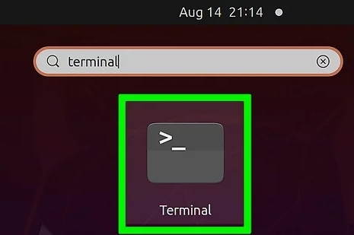

2
Open your command line. Nmap commands are run from the command line, and the results are displayed beneath the command. You can use variables to modify the scan. You can run the scan from any directory on the command line.
- Linux - Open the terminal if you are using a GUI for your Linux distribution. The location of the terminal varies by distribution
- Windows - This can be accessed by pressing the Windows key + R and then typing “cmd” into the Run field. Windows 8 users can press Windows key + X and select Command Prompt from the menu. You can run an Nmap scan from any directory.
- Mac OS X - Open the Terminal application located in the Utility subfolder of your Applications folder.

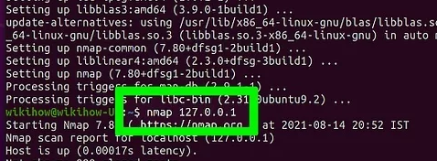

3
Run a scan of you target’s ports. To start a basic scan, type nmap <target>. This will ping the target and scan the ports. This is an easily-detected scan. The results will be displayed on your screen. You may need to scroll back up to see all of the results.

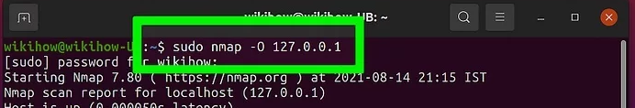

4
Run a modified scan. You can use command line variables to change the parameters of the scan, resulting in more detailed or less detailed results. Changing the scan variables will change the intrusiveness of the scan. You can add multiple variables by placing a space between each one. Variables come before the target: nmap <variable><variable><target>[3]
- -sS - This is a SYN stealth scan. It is less detectable than a standard scan, but may take longer. Many modern firewalls can detect an –sS scan.
- -sn - This is a ping scan. This will disable port scanning, and will only check to see if the host is online.
- -O - This is an operating system scan. The scan will attempt to determine the operating system of the target.
- -A - This variable enables several of the most commonly used scans: OS detection, version detection, script scanning, and traceroute.
- -F - This enables fast mode, and will reduce the number of ports scanned.
- -v - This will show more information in your results, making them easier to read.

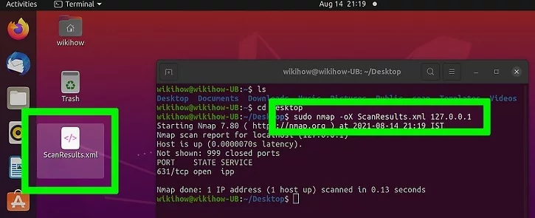

Output the scan to an XML file. You can set your scan results to be outputted as an XML file so that you can easily read them in any web browser. To do this, you will need to use the -oX variable, as well as set a filename for the new XML file. A completed command would look similar to nmap –oX Scan Results.xml <target>.
- The XML file will be saved to whatever your current working location is.

15. Operating System Detection using Nmap

OS Detection in Nmap
NMAP stands for Network Mapper which is an open-source tool used for network exploration and security auditing, in comparison to this, a tool named Nessus is used by industry professionals. These tools are mainly used by cybersecurity experts and hackers.

OS detection using NMAP
Now we need to run the actual commands to perform OS detection using NMAP, and at first, we will get the IP address of the host system, and then will perform a scan to get all active devices on the network.
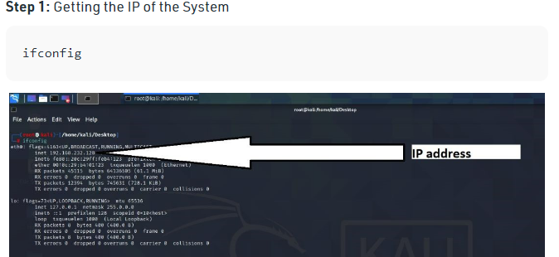

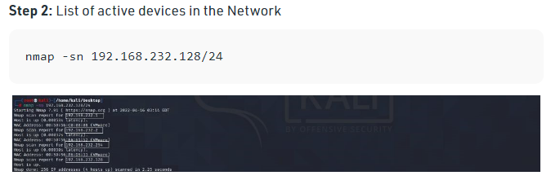
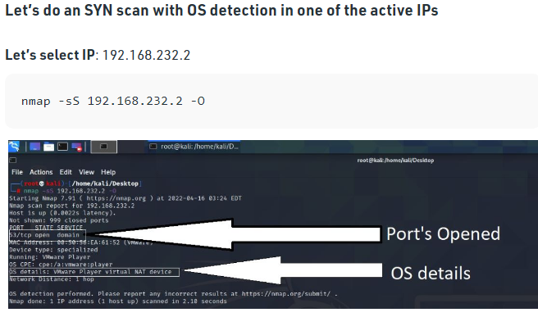

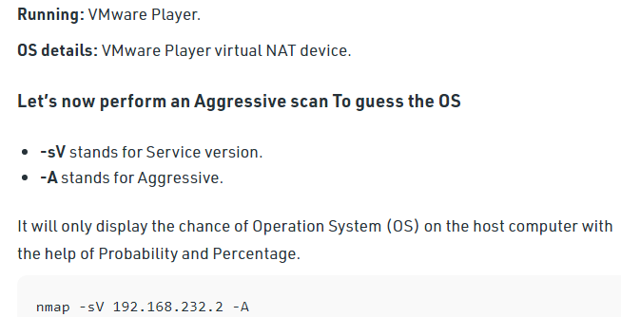

16. Do the following using NS2 Simulator
i. NS2 Simulator-Introduction
ii. Simulate to Find the Number of Packets Dropped
iii. Simulate to Find the Number of Packets Dropped by TCP/UDP
iv. Simulate to Find the Number of Packets Dropped due to Congestion
v. Simulate to Compare Data Rate& Throughput.EXPERIMENT1:

i)NS2 simulator introduction
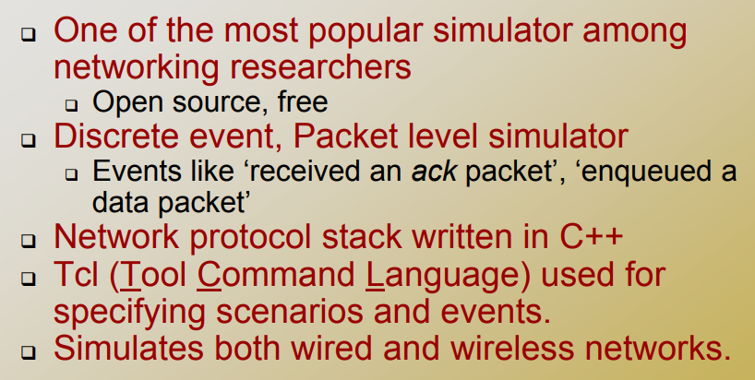
ii)simulate to find number of packets dropped

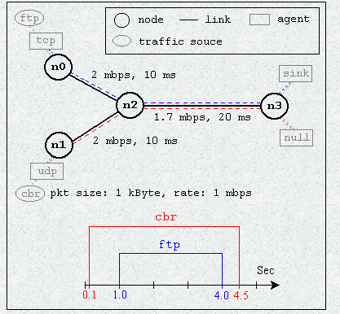

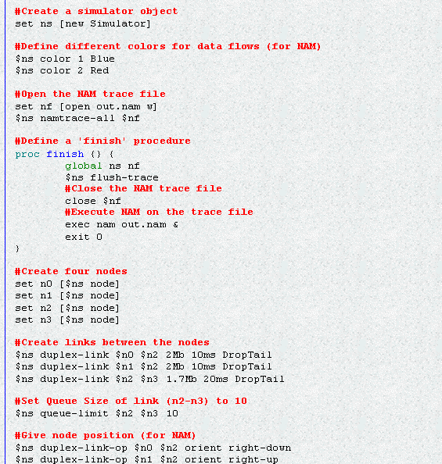
Column 1 represents event type (s: send, r: receive, d: drop, f: forward)
Columns 2 and 3 provide time of the event.
Columns 4 to 7 provide next-hop information.
Columns 8 to 21 are called node property tags.
Column 11 gives the reason for a packet drop and the various reasons possible for a packet drop are as follows.
END drop due to end of simulation
COL drop due to collision at MAC layer
DUP drop due to duplicate packet
ERR drop due to MAC packet error

RET drop due to exceeding retry count
STA drop due to MAC invalid state
BSY drop due to MAC busy
NRTE drop due to no route available
LOOP drop due to routing loop
TTL drop due to TTL=0
TOUT drop due to packet expired
IFQ drop due to no buffer space in IFQ
ARP dropped ARP
OUT dropped by base stations

